Circles- Marking Scheme

June 2018 Mathematics Advanced Paper 1: Pure Mathematics 1

May 2019 Mathematics Advanced Paper 1: Pure Mathematics 1

May 2018 Mathematics Advanced Paper 1: Pure Mathematics 1

May 2017 Mathematics Advanced Paper 1: Pure Mathematics 2

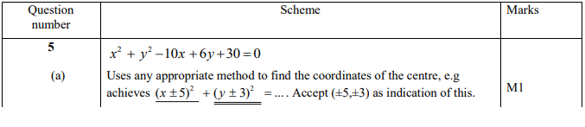

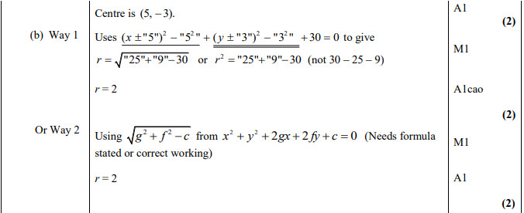

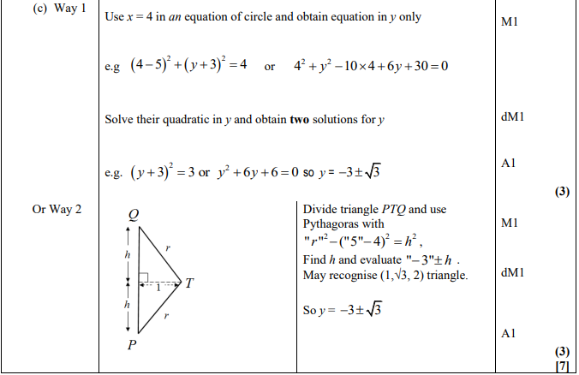

May 2015 Mathematics Advanced Paper 1: Pure Mathematics 2

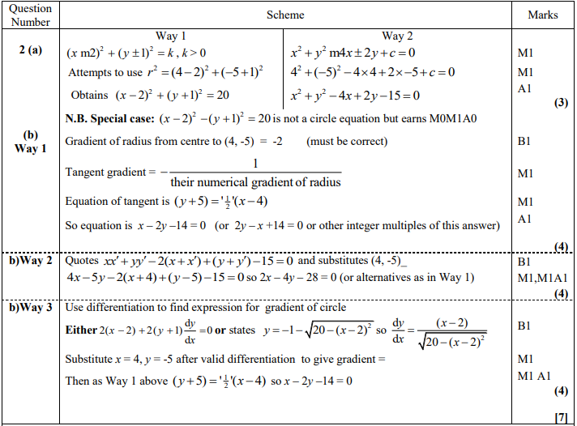

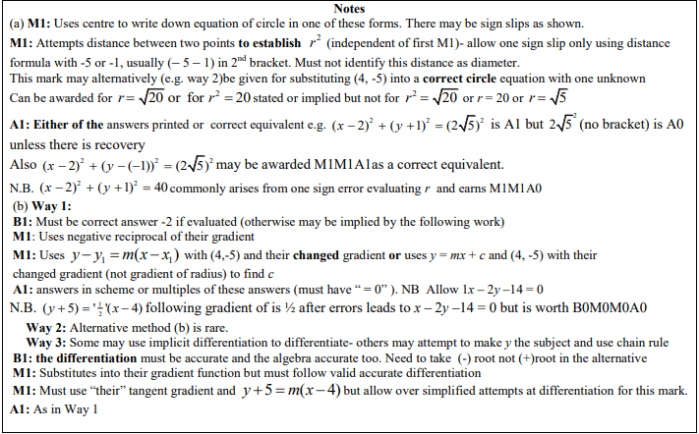

May 2014 Mathematics Advanced Paper 1: Pure Mathematics 2

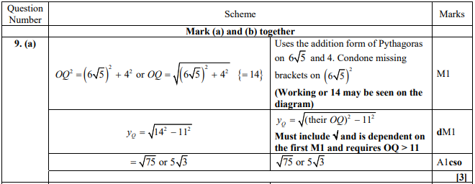

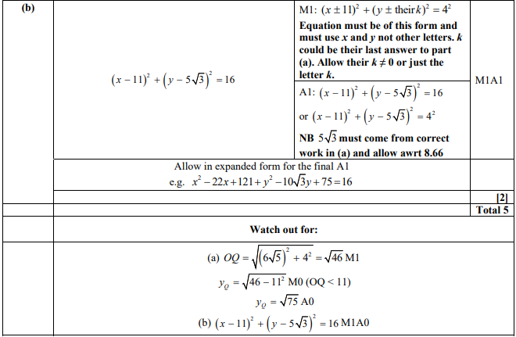

May 2013 Mathematics Advanced Paper 1: Pure Mathematics 2

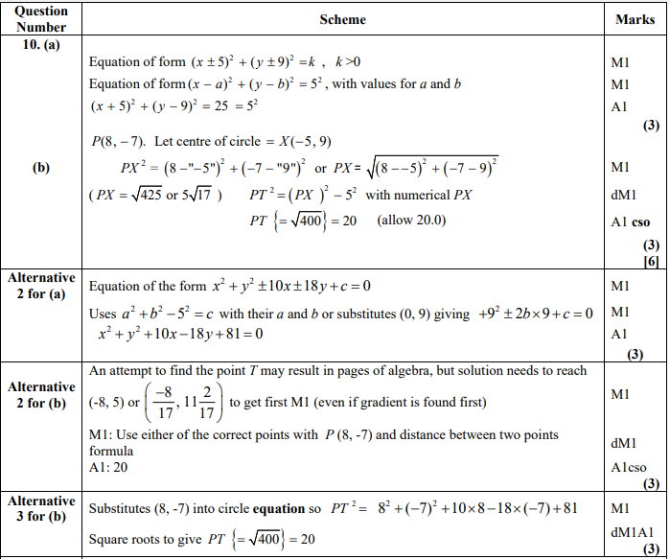

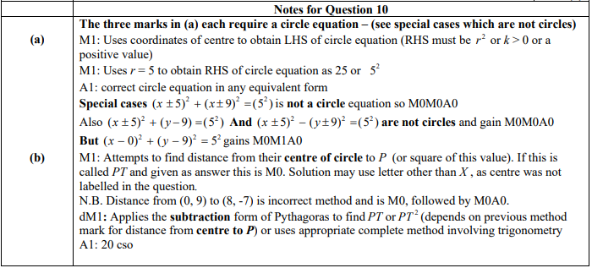

Jan 2013 Mathematics Advanced Paper 1: Pure Mathematics 2

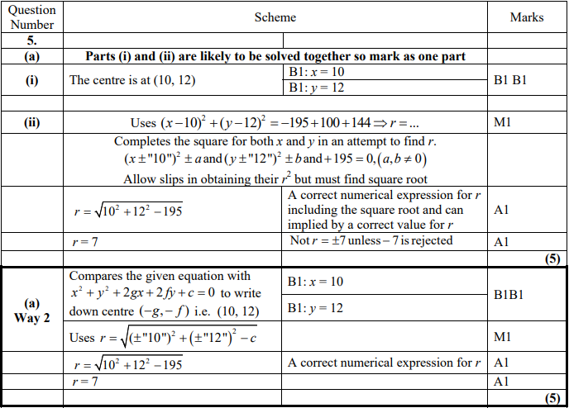

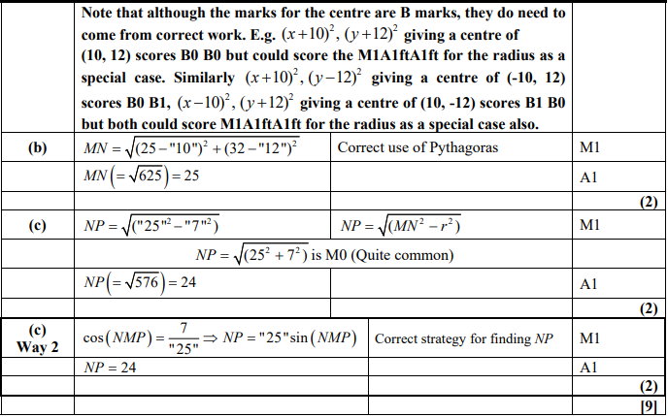

May 2012 Mathematics Advanced Paper 1: Pure Mathematics 2

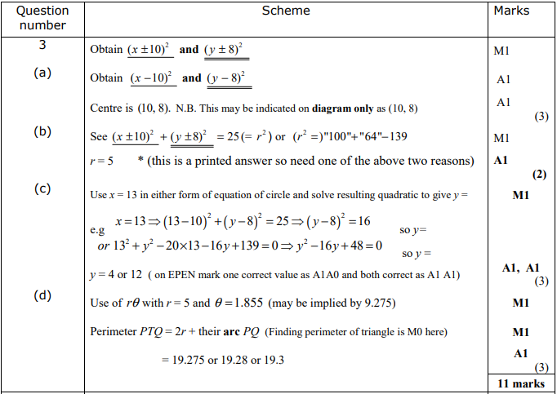

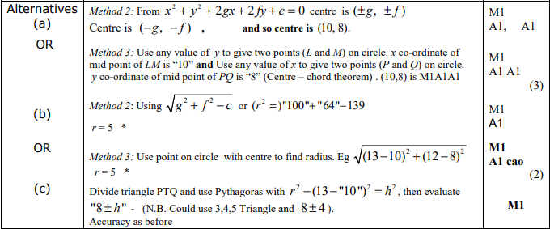

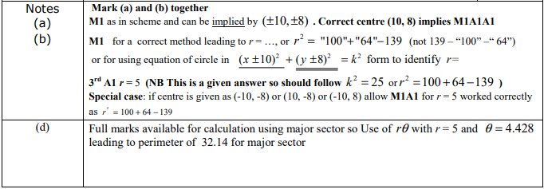

Jan 2012 Mathematics Advanced Paper 1: Pure Mathematics 2

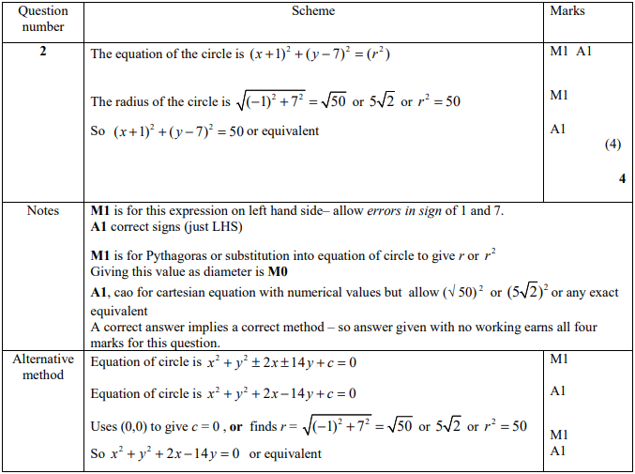

May 2011 Mathematics Advanced Paper 1: Pure Mathematics 2

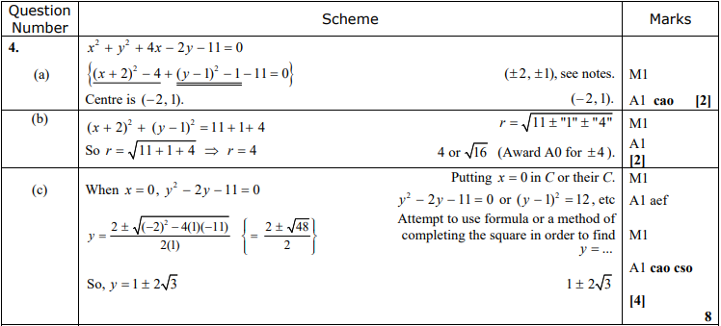

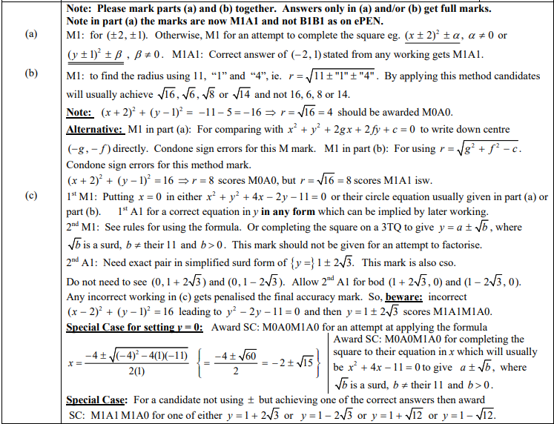

Jan 2011 Mathematics Advanced Paper 1: Pure Mathematics 2

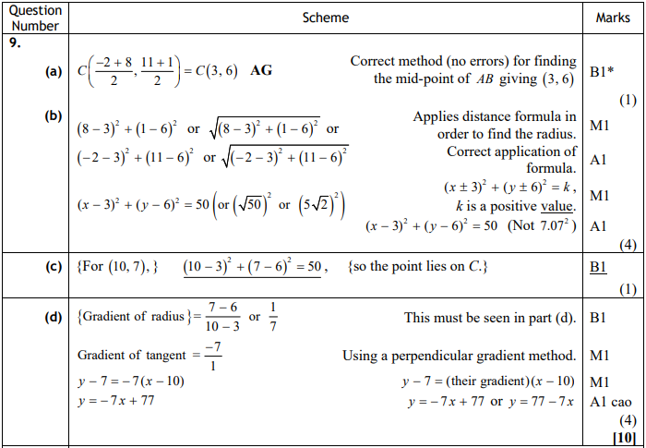

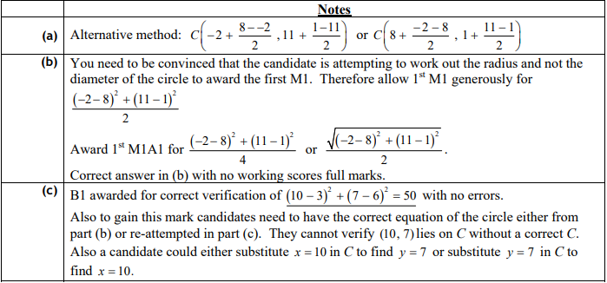

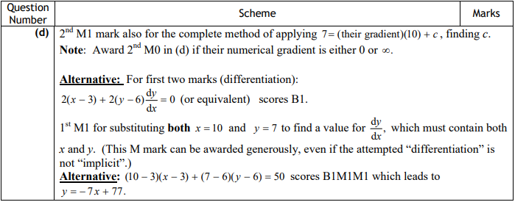

Jun 2010 Mathematics Advanced Paper 1: Pure Mathematics 2

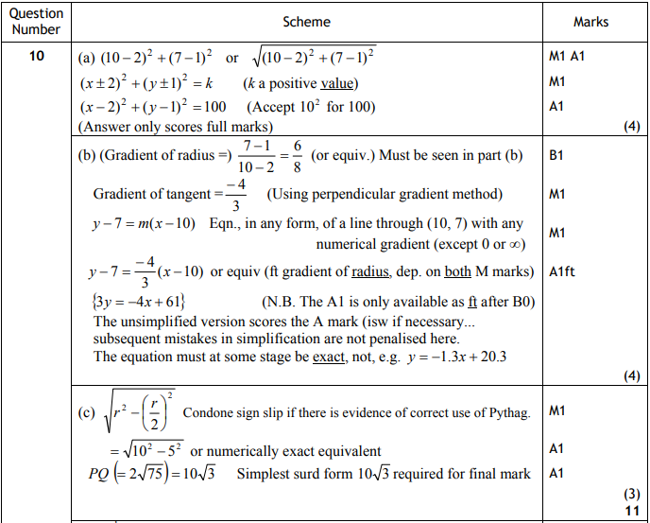

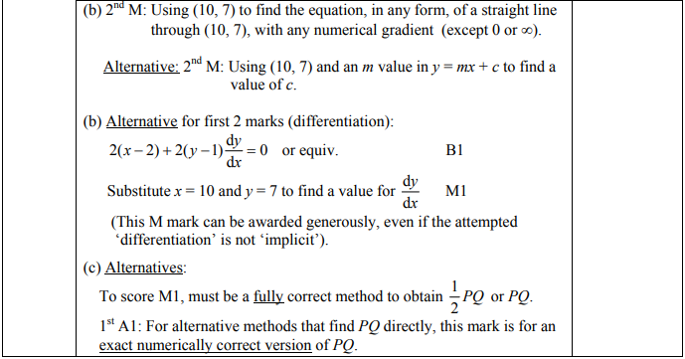

Jan 2010 Mathematics Advanced Paper 1: Pure Mathematics 2

